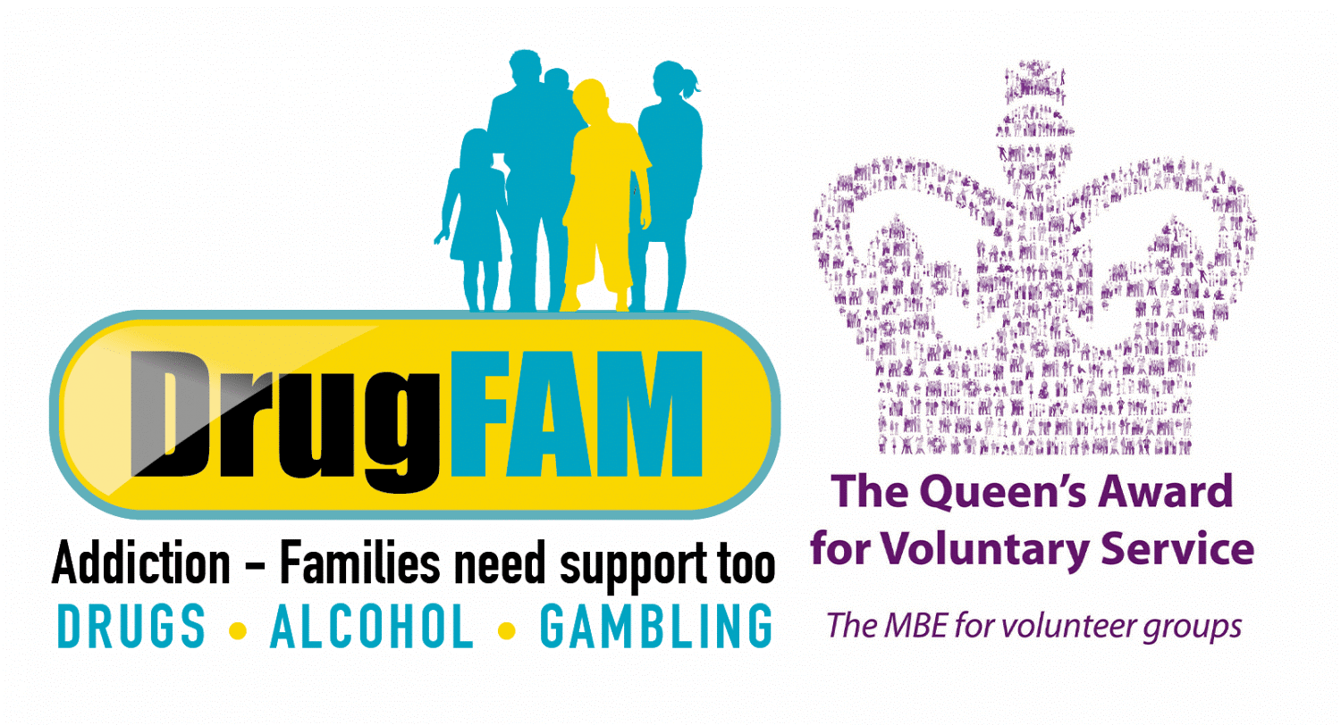
DrugFAM Donation Form
For anyone wanting to make a one-off donation or regular donations to DrugFAM.

By cheque
Please make your cheque / CAF voucher payable to DrugFAM and return with this form to our office address: DrugFAM, Oakley Hall, 8 Castle Street, High Wycombe, Bucks, HP13 6RF.
Please remember to include your contact details. Please consider adding Gift Aid to your donation, using this form, details below.

By standing order / bank transfer
Please email office@drugfam.co.uk for details of DrugFAM’s bank account.

Adding gift aid to your donation
Please complete the declaration below, making sure you add your postal address, sign, and post to DrugFAM’s office (address above) or email to office@drugfam.co.uk
(If by email, please declare on your email that you have signed this form)

GIFT AID. It is very likely that we can claim the tax on your donations – If you are a UK taxpayer, please tick the ‘Gift Aid’ box below and make your donations worth much more, through Gift Aid. As long as you pay an amount of income and/or capital gains tax for each tax year (6th April one year to 5th April the next) that is at least equal to the value of the basic rate tax that we will claim on your donations made in that tax year, you can Gift Aid your donations. For every £1 you donate, Gift Aid allows us to claim at least 25p from HM Revenue & Customs – increasing the value of your gift at no cost to you. Most people pay some form of income and/or capital gains tax on their income, pension savings or investments.

Please tick box ☐

I am a UK taxpayer and understand that if I pay less Income Tax and/or Capital Gains Tax than the amount of Gift Aid claimed on all my donations in that tax year it is my responsibility to pay any difference. Please treat all donations I make or have made to DrugFAM / The Nicholas Mills Foundation for the past 4 years as Gift Aid donations until further notice.

Please notify us if you want to cancel this declaration, change your name or your home address, no longer pay sufficient tax on your income and/or capital gains. If you pay income tax at the higher or additional rate and want to receive the additional tax relief due to you, you must include all your gift aid donations on your self-assessment tax return or ask HM Revenue and Customs to adjust your tax code.

Title:
Name:
Signature:
Date:
Address:  Postcode:  Thank you for your support! Registered charity in England and Wales (1123316) | Registered Charity No. 1123316  office@drugfam.co.uk
Thank you!

